*********************************Node Js****************************

API : Application programming interface

* Diffrence between node js and JavaScript :

I ) node js and javascript have same syntax and code

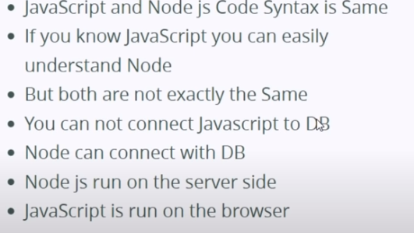

* Basic concept before learning node js :

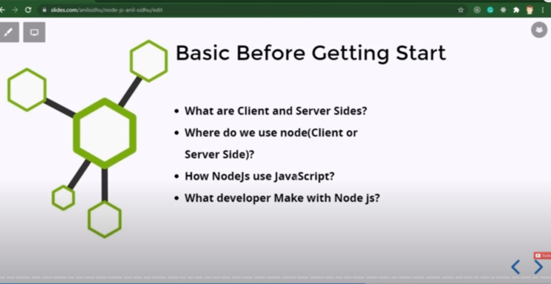

1. What is client and server sides ?

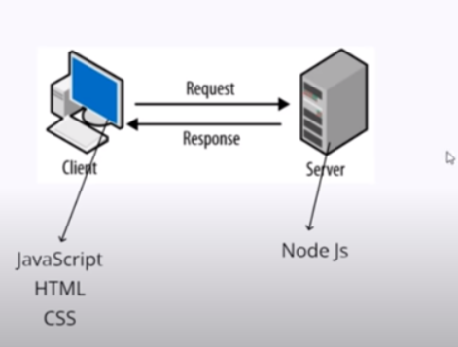

There is also may server side language like : python , php node js .

They send information in form of APIs to client side .

🡺 what do we do with node js ?

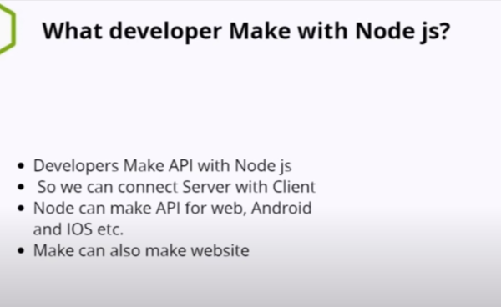

3 . How node js using javascript ?

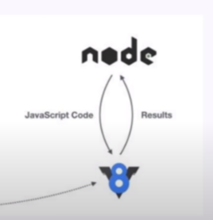

🡺 Running node js on command prompt :

1 . to check wheter it is download or not we can check its version by (node -v enter )

2 . To run node js we need to (node enter ) in cmd .

Note : Durning writing node js on console or cmd whenever we define anything or printing any thing it is showing undifine it is because we are not returning any thing .

🡺 Running node js in vs code :

In terminal write : node .\js file name

🡺 Exporting something from other node js file :

*module*.*exports*={

    x:10,

    y : 15,

}

Export to :

*const* app=require("./app") // file name

console.log(app.x)

🡺 Module :

1.Core Module : example -> console.log(),filesystem(fs),buffer , HTTP;

🡺 In core module we have :

1. Global module : we do not need to import ,console.log();
2. Non-Global module :we need to import them .

Example :1. const fs=require(‘fs’);

Fs.writeFileSync(“hello.txt”,”code step by step”);

🡺 Making a basic server(2.http)

const http=require(“http”);

note : http -> handle the request and response of the server .

*const* http = require("http");

http

  .createServer((*reqs*, *resp*) *=>* {

*resp*.write("Hello World !");

*resp*.end();

  })

  .listen(4500);

🡺 pakage.jason :

1. To create package manger

Step 1 : in command pallet /new terminal write : npm init ;(node package manger full form of npm)

2 . we can import many packages

Ex . npm color pakage

Note if node_module get delete : then our install pakage will not going to run .

In order to reinstall we need to in terminal : npm install

(then press Enter) .

Note : since node_module file is big like in mb even sometime in gb . while pussing it on git we can ignore it because the other user will going to get it by npm install .

We can do this by creating a file : .gitignore

In .gitignore file write : /node_modules

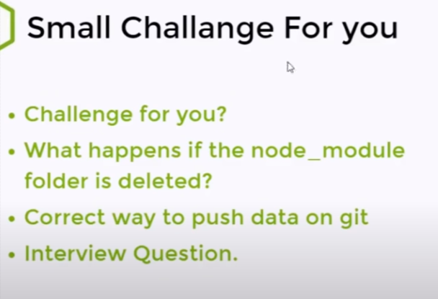1.ans : if the node_module will get delete then we can reinstall it with :npm install

2. we don’t push node_module on git we can do this by creating new file : .gitignore -> in that gitignore we can write : /node_modules it will not going to push it on the git .